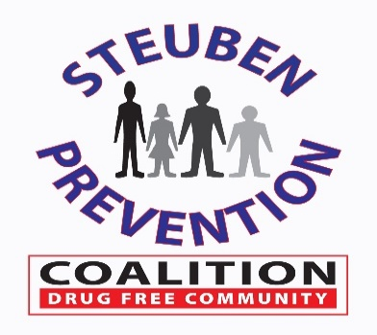
Coalition Meeting

Chair: Hilda lando

Co-Chair: Amanda Chafee

Recording Member: Colleen Banik
Colleen Banik
DFC Program Coordinator
23 Liberty Street
Bath, New York 14810
(607) 776-8085
Meeting Minutes
January 12, 2022

Member | Attendance | Member | Attendance
Pam Aini |  | Jim Allard
Colleen Banik | X | Brooks Baker
Stacey Wing | X | Hilda Lando | X
Kory Bay |  | Jerry Bennett | X
Krystle Blencowe |  | Brandon Beuter | X
Laura Bingell |  | Heidi Burns
Scott Carroll |  | Bill Caudill
Amanda Chafee | X | Hank Chapman
Kevin Costello |  | Jennifer Crane
Hadley Slayton |  | Bianca Crandle | X
Thomas Crook |  | Cheryl Crocker
Kevin Grover |  | Jesse Harper
Susan Hooker |  | Matt Jones
Jeannie Wheeler |  | Kyle King | X
John McNelis |  | Dan Chapman
Nick Moffe |  | Mark Recktenwald
Ted Murray |  | Lisa Oliver
Sarah Welch |  | David Robinson
Pansy VanTreese |  | Joe Rumsey | X
Connie Terry | X | Paul Shephard
Lorelei Wagner |  | Dave Taylor-Smith
Jack Wheeler |  | Jennie Knox | X
Patricia Tucker |  | Audrey Bickle | X
Mary Pleakis | X | Andrew Rosenbarker | X
Guest – Kelli Keck | X

Welcome/Introductions:

Chair, Hilda Lando, opened the January 2022 meeting and introductions were made around the zoom room. Special welcome and introductions were made for Audrey Bickle, Prevention Specialist of Family Service Society, Mary Pleakis, Community Engagement & Partnership Coordinator and Andrew Rosenbarker, Pastor of Two River Church in Corning.
Special Announcement:

Stacey Wing presented the William & Dorothy Belknap to our own Joe Rumsey, who is a member of our Coalition, and also the Chairman of the Steering Committee. Stacey presented the award to Joe Rumsey with the following statement:

“The 2021 Award recipient is Mr. Joseph Rumsey, Haverling School District Superintendent. Joe is a major supporter of all things prevention and works daily to keep his students safe, families informed and communities involved. He is the Chair of the Prevention Coalition Steering Committee, he works to keep Prevention Counseling in his district as well as supports us in our classroom efforts. Joe is also highly involved in many community projects and organizations that work to improve our community and to make our area safer for kids to grow and thrive. Thank you for your work and dedication to prevention, your school and your community.”

Congratulations Joe!

November 2021 Meeting Update:

Acceptance of the November 2021 meeting minutes was made following a motion made by Brandon Beuter and seconded by Bianca Crandle.

Annual Evaluation & Coalition Self-Assessment Presentation:

Kelli Keck presented the Epiphany Community Services Annual Evaluation Report for 2021. Kelli focused on the improvements, coordination, accountability, celebration and sustainability of the coalition. Kelli also provided the Coalition total outputs, efforts for general ATOD (all substances combined), specific to alcohol, specific to marijuana and specific to opioids. Kelli further recognized the Coalition success and provided recommendations for going forward. (See slides included below)
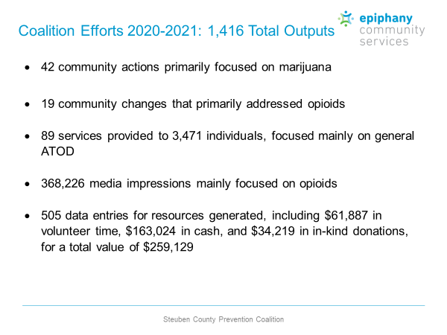
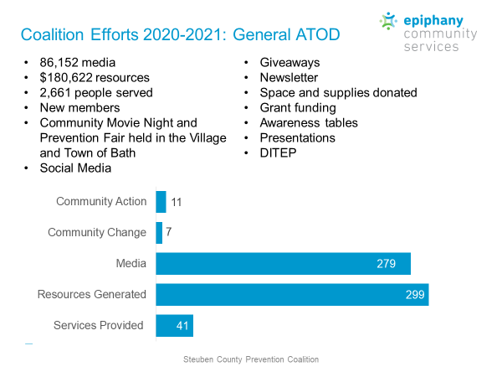
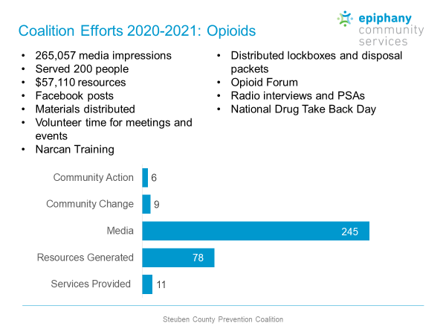
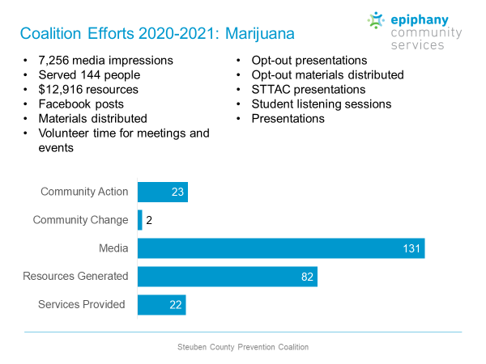
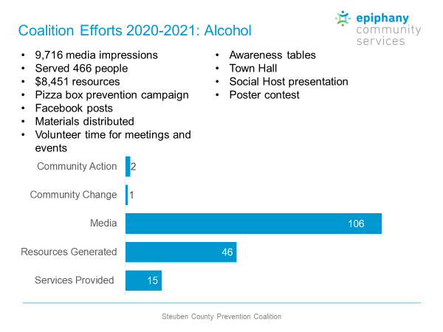
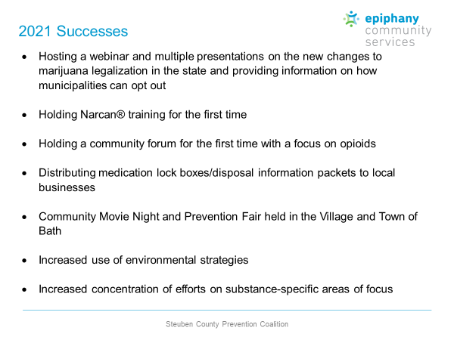
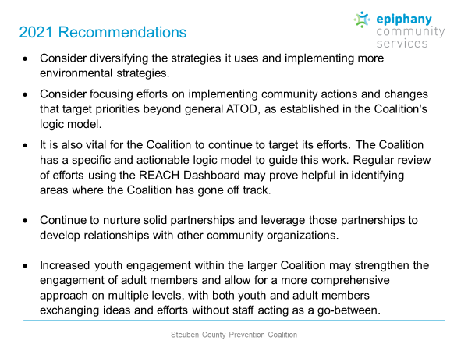
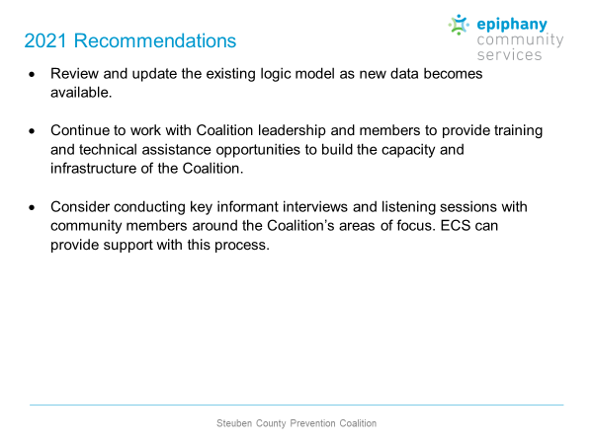

Kelli also presented a review of the results of the 2021 Coalition Self-Assessment Survey providing an overview of the results, a review of the number of members needed to effectively complete the work plans and strategies developed, coalition weaknesses, coalition strengths and the barriers to participation in the coalition as reported by the participating members who took the survey. (See slides included below)

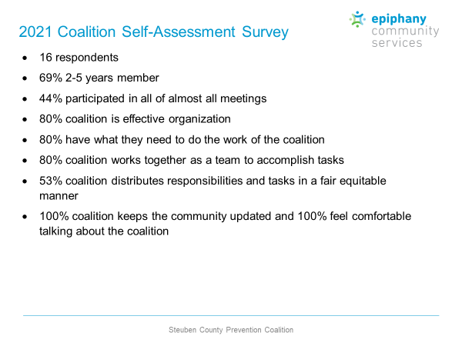
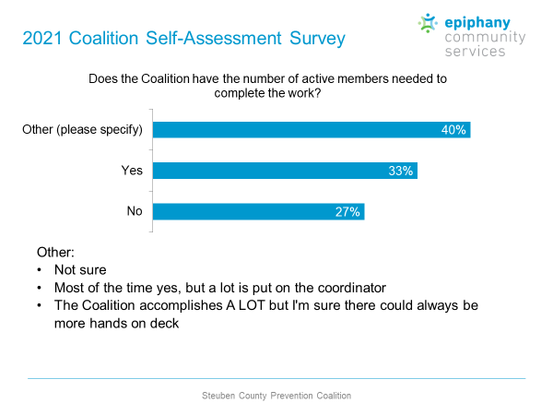
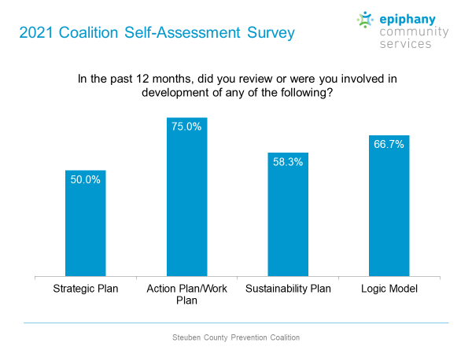
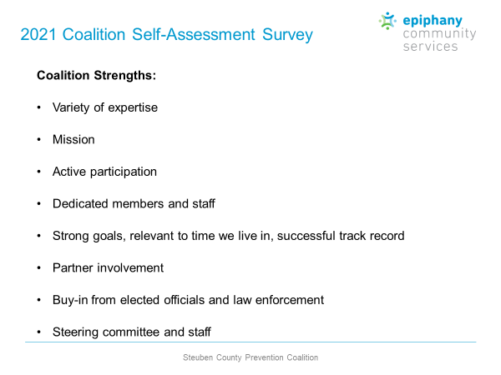
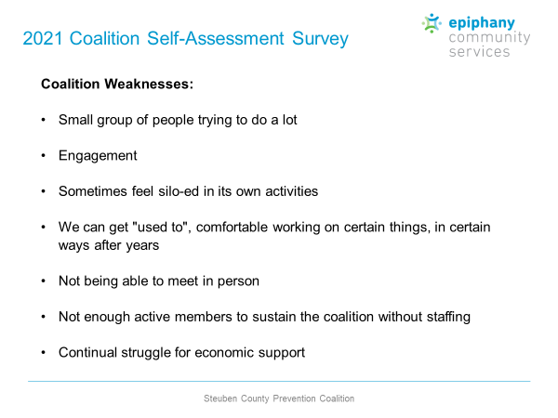
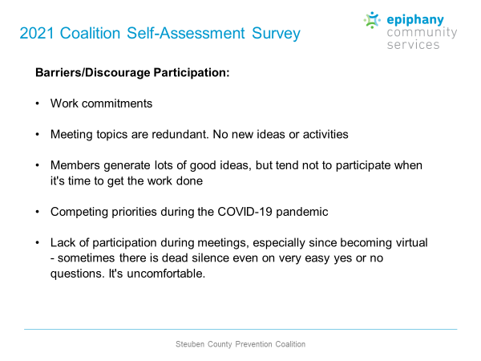

A group discussion followed the presentation indicating that lack of participation remains one of the biggest problems, new member onboarding and orientation needs to be stepped up, members need to better utilize the volunteer activity reporting sheets and accountability for hours spent on coalition efforts.

2022 Work Plan:

Colleen Banik provided the ongoing 2022 Work Plan via email prior to the meeting. A general discussion of events/activities was limited due to time constraints. Colleen also reported that we finally received the DFC Grant Year 8 Notice of Award on December 15, 2021, the Prevention Needs Assessment Survey closed out with 2,540 students participating with 11 school districts participating. Colleen also reported that the Steuben County Sheriff’s Department Memorial Stock Trailer Project continues to be under construction. The Coalition updated their graphic with 2021 Prevention Needs Assessment Data and provided to the Sheriff’s Department in early January. (See slide included below)

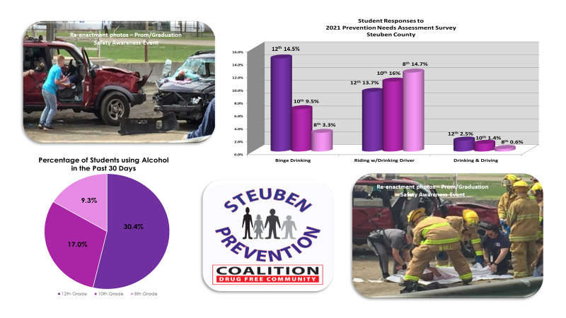

2022 Chair & Co-Chair Leadership Nomination Process

The 2022 Nomination Process for our Chair and Co-Chair Leaders is finalized (see slide included below) and will be submitted to the Steering Committee for approvoal on January 25, 2022.

2020 - 2021 Sitting Chair/Co-Chairs
- Coalition | Chair | Hilda Lando
 | Co-Chair | Amanda Chafee
- Steering Committee | Chair | Joe Rumsey
 | Co-Chair | Kory Bay
- UAD Task Force | Chair | Stacey Wing
 | Co-Chair | Colleen Banik
- Marijuana Task Force | Chair | Amanda Chafee
 | Co-Chair | Stacey Wing
- Opioid Committee | Chair | Brandon Beuter
 | Co- Chair | Hilda Lando
2022 Nominations |  | Nominees
- Coalition | Chair | Hilda Lando - accepted
 | Co-Chair | Amanda Chafee - accepted
- Steering Committee | Chair | Joe Rumsey - accepted
 | Co-Chair | Kory Bay - accepted
- UAD & Marijuana Prevention Task Force | Chair | Stacey Wing – accepted - UAD
 | Chair | Audrey Bickle – accepted - MJ
- Opioid Task Force | Chair | Brandon Beuter - accepted
 | Co-Chair | Hilda Lando - accepted
Task Force/Committee Updates:

Due to presentations during today’s meeting, the task force breakout sessions were tabled.

A group discussion was held and agreed upon by the Coalition and it's Chair/Co-Chairs of the respective task forces and committees to combine the UAD and Marijuana Task Forces (due to limited availability of members) and reduce the number of meetings necessary to carry out the tasks/activities/events of the year. It will now be considered the Underage Drinking & Marijuana Prevention Task Force which will meet bi-monthly with additional meetings scheduled as needed. It was further discussed by the Coalition and it's Chairs/Co-Chairs to reduce the full coalition meeting to 1 hour (due to ​availability of members) with less reporting and increased activity/project planning and recruitment efforts. The Coalition will continue to meet on the same regularly scheduled dates and the new combined Task Force will meet on the same regularly dates as the previous UAD Task Force. All of these revisions will be reflected in revisions to the By-Laws and Community Involvement Agreements.

Stacey Wing gave a brief overview of the UAD Task Force activities and upcoming events to included the Poster/Sticker Design contest, UAD Youth videos and a potential Spring Town Hall Meeting.

Other:

Jerry Bennett announced a free virtual training opportunity by the Prevention Resource Center: Dover Y2Y: Youth Empowerment Adviser Training on February 8th, 2022 from 12:00 p.m. – 4:00 p.m. Cost - $0.00 with a limitation of 30 participants.

Colleen Banik reminded the group that the 2022 Meeting Schedule will be amended according to the changes stated above and will be re-circulated with the minutes.

Adjournment:

Adjournment was approved following a motion to adjourn the regular Coalition meeting by Brandon Beuter and seconded by Jerry Bennett.

Action Item: | Who’s Responsible: | Target Start: | Target Completion:
Coalition/Task Force/Committee Chair and Co-Chair Nominations Slate of Officers to the Steering Committee | Colleen Banik | 11/1/21 | 12/7/21
Coalition Self-Assessment Survey (2021) | Colleen Banik, Coalition Members | 11/1/21 | 11/30/21
DITEP Training to be scheduled | Colleen Banik | 5/1/22 | 7/30/22
Re-circulate 2022 Meeting Schedule | Colleen Banik | 11/1/2021 | 11/30/21  Completed
Circulate 2021 PNA County Report | Colleen Banik | 1/1/21 | 1/31/21
Present 2021 PNA Individual School Reports | Colleen Banik, Stacey Wing, Coalition Members | 1/1/22 | 6/30/22
7 Strategies Education
Role/Job Descriptions
Member Recruitment |  | 1/1/22 | 10/30/22

Next Meeting: March 9, 2022 @ 11:00 a.m.
(Virtually – Zoom link to be distributed at a later date)

