* **Intro/Welcome**
* **February Meeting**
  + Acceptance of Minutes
  + Outstanding Action Item
    - Drug Quiz Info – Lisa Oliver
* **Coalition Report**
  + Media Campaign
    - April/May/June
      * Editorials
      * Awareness Month Articles
  + Prom/Graduation Activities
    - 5 School Participation
  + Tips Training
  + 3rd Millennium Project
    - Implementation in Hornell
  + Tall Cop Final Update
  + Youth Engagement
  + Young Adult/Adult Survey
* **Underage Drinking Task Force Report**
* **Marijuana Prevention Task Force Report**
* **Other**

**Next Meeting: April 25, 2017**

## AGENDA

# Steuben Prevention Coalition

# Steering Committee Meeting

**March 20, 2014**

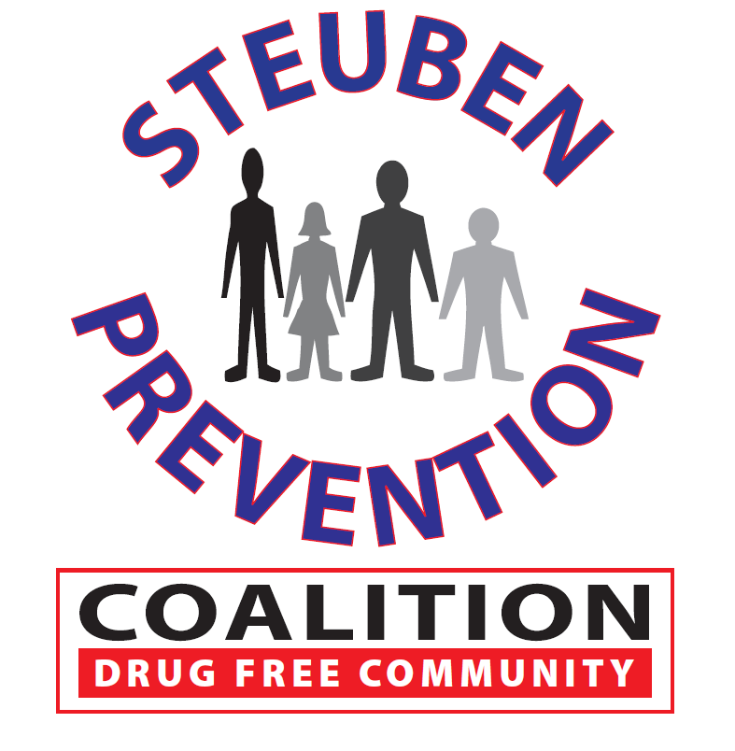

### Date: March 28, 2017

### Time: 9:00 a.m. – 11:30 a.m.

### Location: 115 Liberty Street, Bath, New York