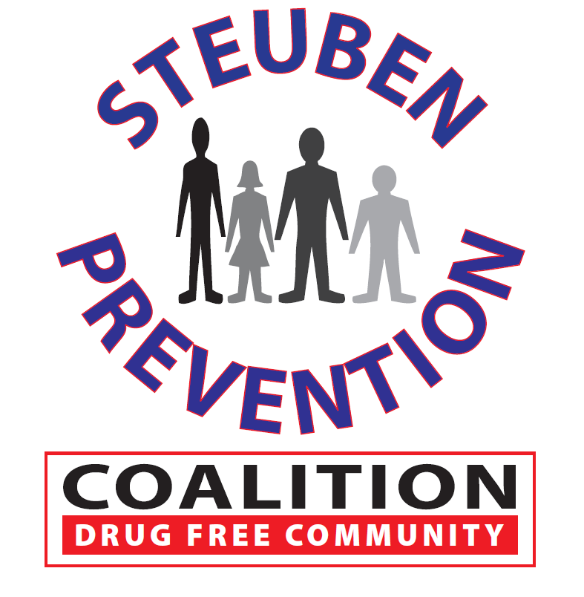

* Task Force Review of Plan
* Approval of Flyers
* Media Discussion
  + Cost Estimates
  + Alternatives
* Other

Next meeting to be held on

April 18, 2019

8 East Morris Street, Bath, NY

### Time: 11:00 a.m.

### Steuben Co. Sheriff’s Bld.

### 7007 Ramsey St. Extension

### Bath, New York 14810

# Marijuana Prevention Task Force

**March 13, 2019**

## AGENDA