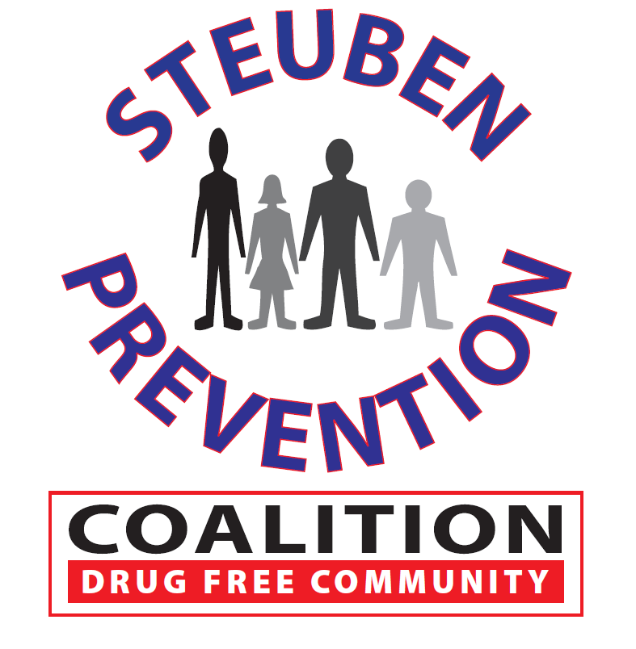

* Task Force Review
* Review of Recent Conferences
* Discussion of Next Steps
  + Contact Legislators
  + Write Op-Eds
  + Develop Elevator Speach
* Other

Next meeting to be held on

May 8, 2019

Steuben County Sheriff’s Office, Bath, NY

### Time: 2:00 p.m.

### Catholic Charities Bld.

### 8 East Morris Street

### Bath, New York 14810

# Marijuana Prevention Task Force

**April 18, 2019**

## AGENDA