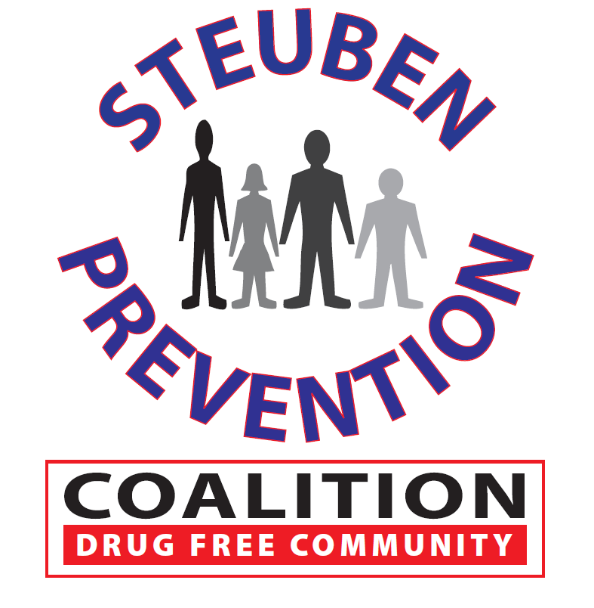

* Tall Cop – review and comments
* School Posters – last one this year
* Recognition Awards
* PSA’s
* Youth Engagement
* Pride Surveys
* Young Adult/Adult Opiate Surveys
* DITEP – July 5 - 6

### Time: 2:00 p.m.

### Steuben Council on Addictions

### 8 East Morris Street

### Bath, New York 14810

# Marijuana Prevention Task Force

**April 20, 2017**

## AGENDA