**July 2016 Volume 1, Issue 2**

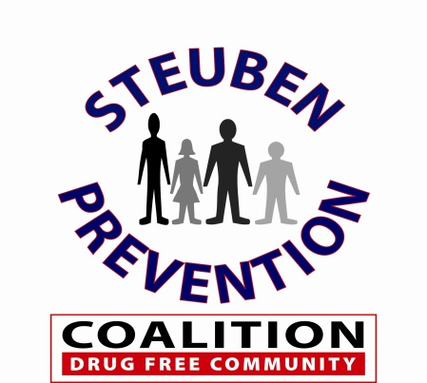

Ounce of Prevention

Newsletter

**Inside this Issue:**

* Message to Coalition Members
* Teens’ Likelihood of Trying Marijuana – Study from the University of Florida
* AMA Calls for Ban on Powdered Alcohol
* Trending – Heroin
* House of Reps passes CARA
* Myths vs. Facts on Alcohol and Marijuana
* Underage Drinking Poster Contest
* Upcoming Events

**Message to Coalition Members:**

Welcome to new Coalition Member, Laura Vetter, Community Services Supervisor at St. James Mercy Hospital.

DITEP Training held on July 6 & July 7 was a great success with over 30 participants in the class.

We are pleased to have five Coalition Members attending the CADCA Mid-Year Conference this month from July 17 – July 22 in Las Vegas.

**Article:**

***Study Finds Teens’ Likelihood of Trying Marijuana Peaks at***

***Ages 16 and 18***

The likelihood adolescents will try marijuana rises steadily from age 11 to age 16, then decreases before hitting another peak at age 18, according to a new University of Florida study.

The study findings, which appear in the American Journal of Drug and Alcohol Abuse, may help experts develop new marijuana prevention strategies, says lead author Xinguang (Jim) Chen, M.D., Ph.D., a professor in the department of epidemiology in the UF College of Public Health and Health Professions and the UF College of Medicine.

“Many existing marijuana intervention programs target students age 15 and older,” Chen said. “Our findings demonstrate the need to start drug education much earlier, in the fourth or fifth grade. This gives us an opportunity to make a preemptive strike before they actually start using marijuana.”

As medical marijuana laws are passed in more states, there is concern among some experts that teens may view marijuana as a substance that can be used safely by anyone, regardless of whether it is part of a treatment plan under a physician’s supervision.

The UF study was designed to learn when adolescents are most at risk for starting marijuana use. It is one of the first studies to examine the likelihood of marijuana initiation as a function of age and it used a study method called survival analysis that is more sensitive to fluctuations across age groups, Chen said in a news release.

The team analyzed data from the 2013 National Survey on Drug Use and Health, a nationwide cross-sectional survey including approximately 27,000 respondents ages 12 to 21, sponsored by the Substance Abuse and Mental Health Services Administration (SAMHSA).

**Steuben Prevention Coalition**

**8 East Morris Street**

**Bath, NY 14810**

**(607) 776-6441**

**Website:** SteubenPreventionCoalition.org

**Email:** [SteubenPreventionCoalition@gmail.com](mailto:SteubenPreventionCoalition@gmail.com)

**Staff:**

**Norman McCumiskey**

**Program Coordinator**

**Colleen Banik**

**Program Assistant**

**Article:**

***“American Medical Association Calls for Ban on Powdered Alcohol”***

*AMA – June 22, 2016*

The American Medical Association (AMA) is calling for a ban on powdered alcohol to protect young people, Medscape reports. The group notes alcohol is the most widely used substance of abuse among young people, leading to 4,300 underage deaths annually.

Powdered alcohol is not yet available in the United States, the article notes. The product, to be sold under the brand name Palcohol, could be snuck into school by teens, the AMA warned.

The AMA House of Delegates voted at the group’s annual meeting last week to support federal and state laws that prohibit the manufacture, importation, distribution, and sale of powdered alcohol.

“Given the variety of flavors that could be enticing to youth and concerns that the final alcohol concentration could be much greater than intended by the manufacturer, we believe that powdered alcohol has the potential to cause serious harm to minors and should be banned,” AMA Board Member Jesse M. Ehrenfeld, MD, said in a news release. “We urge states and the federal government to prevent powdered alcohol from being manufactured, distributed, imported and sold in the U.S.”

The AMA’s Council on Science and Public Health concluded that the danger that could come from mixing powdered alcohol with liquid alcohol or energy drinks “raises the potential for dangerous patterns of use.”

No research has yet been conducted on the potential health risks of Palcohol, the council noted. However, the group said, “previous experience with novel alcohol products that appealed to youth, including alcohol energy drinks, has demonstrated the potential for overuse and harm.”

In 2015, U.S. Senator Charles Schumer of New York introduced a measure to ban the production, sale and possession of powdered alcohol. Schumer’s announcement came two days after a federal agency announced it had approved sale of the product.

**Trending: Heroin**

**Deaths Involving Heroin More Than Tripled Between 2010 and 2014:**

**DEA - June 30th, 2016**

The number of deaths in the United States involving heroin more than tripled between 2010 and 2014, according to a new report by the Drug Enforcement Administration (DEA). The number of people reporting current heroin use nearly tripled between 2007 and 2014, the agency said.

The DEA’s 2016 National Heroin Threat Assessment Summary found 425,000 people said they used heroin in the past month in 2014, and 10,574 people died from the drug. Deaths due to synthetic opioids, such as fentanyl and similar drugs, increased 79 percent between 2013 and 2014.

Many people who use prescription opioid painkillers become addicted, and then switch to heroin because it is cheaper and easier to obtain than illegal prescription drugs, the DEA noted.

The rise in heroin deaths may be partly due to an increase in people who are new to the drug and inexperienced in its use, ABC News reports. Highly toxic adulterants such as fentanyl, which is being mixed into heroin in certain markets, also plays a role, the DEA stated.

The heroin threat is greatest in the Northeast and Midwest. Mexican drug traffickers have gained a larger share ofthe biggest heroin markets in the United States, including Baltimore, Boston, Chicago, New York, Philadelphia and Washington, D.C., the report found. Traffickersalso moved their operations into suburban and rural areas. “We tend to overuse words such as “un-precedented” and ‘horrific,’ but the deathand destruction connected to heroin and opioids is indeed unprecedented and horrific,” DEA Acting Administrator Chuck Rosenberg said in a news release. “The problem is enormous and growing, and all of our citizens need to wake up to these facts.”

Earlier this week, the United Nations Office on Drugs and Crime released a report that estimates one million people usedheroin in the United States in 2014, almost triple the 2003 rate. Heroin-related deaths haveincreased five-fold since 2000, the World Drug Report 2016 found.

**June 2016 Page 2 Volume 1, Issue 1**

**Breaking: House of Representatives Passes CARA**

Today the U.S. House of Representatives, in a bi-partisan effort, voted 407-5 to pass the historic Comprehensive Addiction and Recovery Act (CARA) Conference Committee bill. CARA is the most comprehensive effort undertaken to address the opioid epidemic, encompassing all six pillars necessary for a comprehensive response – prevention, treatment, recovery, law enforcement, criminal justice reform, and overdose reversal. Passage of this legislation in the U.S. House of Representatives marks a monumental achievement for the field of addiction.

"CARA recognizes the vital importance of prevention and provides critical enhancement grants to current and former Drug-Free Communities grantees to combat prescription drug and methamphetamine abuse in their communities. This comprehensive bill lays the groundwork to turn the tide on the opioid epidemic, which is killing 129 people a day. The time to get CARA to the President's desk has never been more crucial."

While CARA has made significant progress, it still has one more step before it can be signed into law by the President. This legislation must pass the Senate before it clears Congress and can make its way to the White House.

**Underage Drinking Poster Contest**

The Steuben Prevention Coalition’s Under Age Drinking Task Force sponsored a countywide alcohol poster contest for youth in grades 5,6 &,7. This was done during the month of April to promote April is National Alcohol Awareness

Month. The youth were asked to develop posters that would provide anti -drinking messages to their peers. The contest had over 180 entries from

across the county and prizes were awarded for first, second and third place.

The Task Force would like to thank the Steuben Trust Company and the S2AYA Network for providing donations to support this contest.

First Place-Mya Rusak- Dana Lyons Middle School, Bath. Mya’s poster design will be made into t-shirts for her and her classmates.

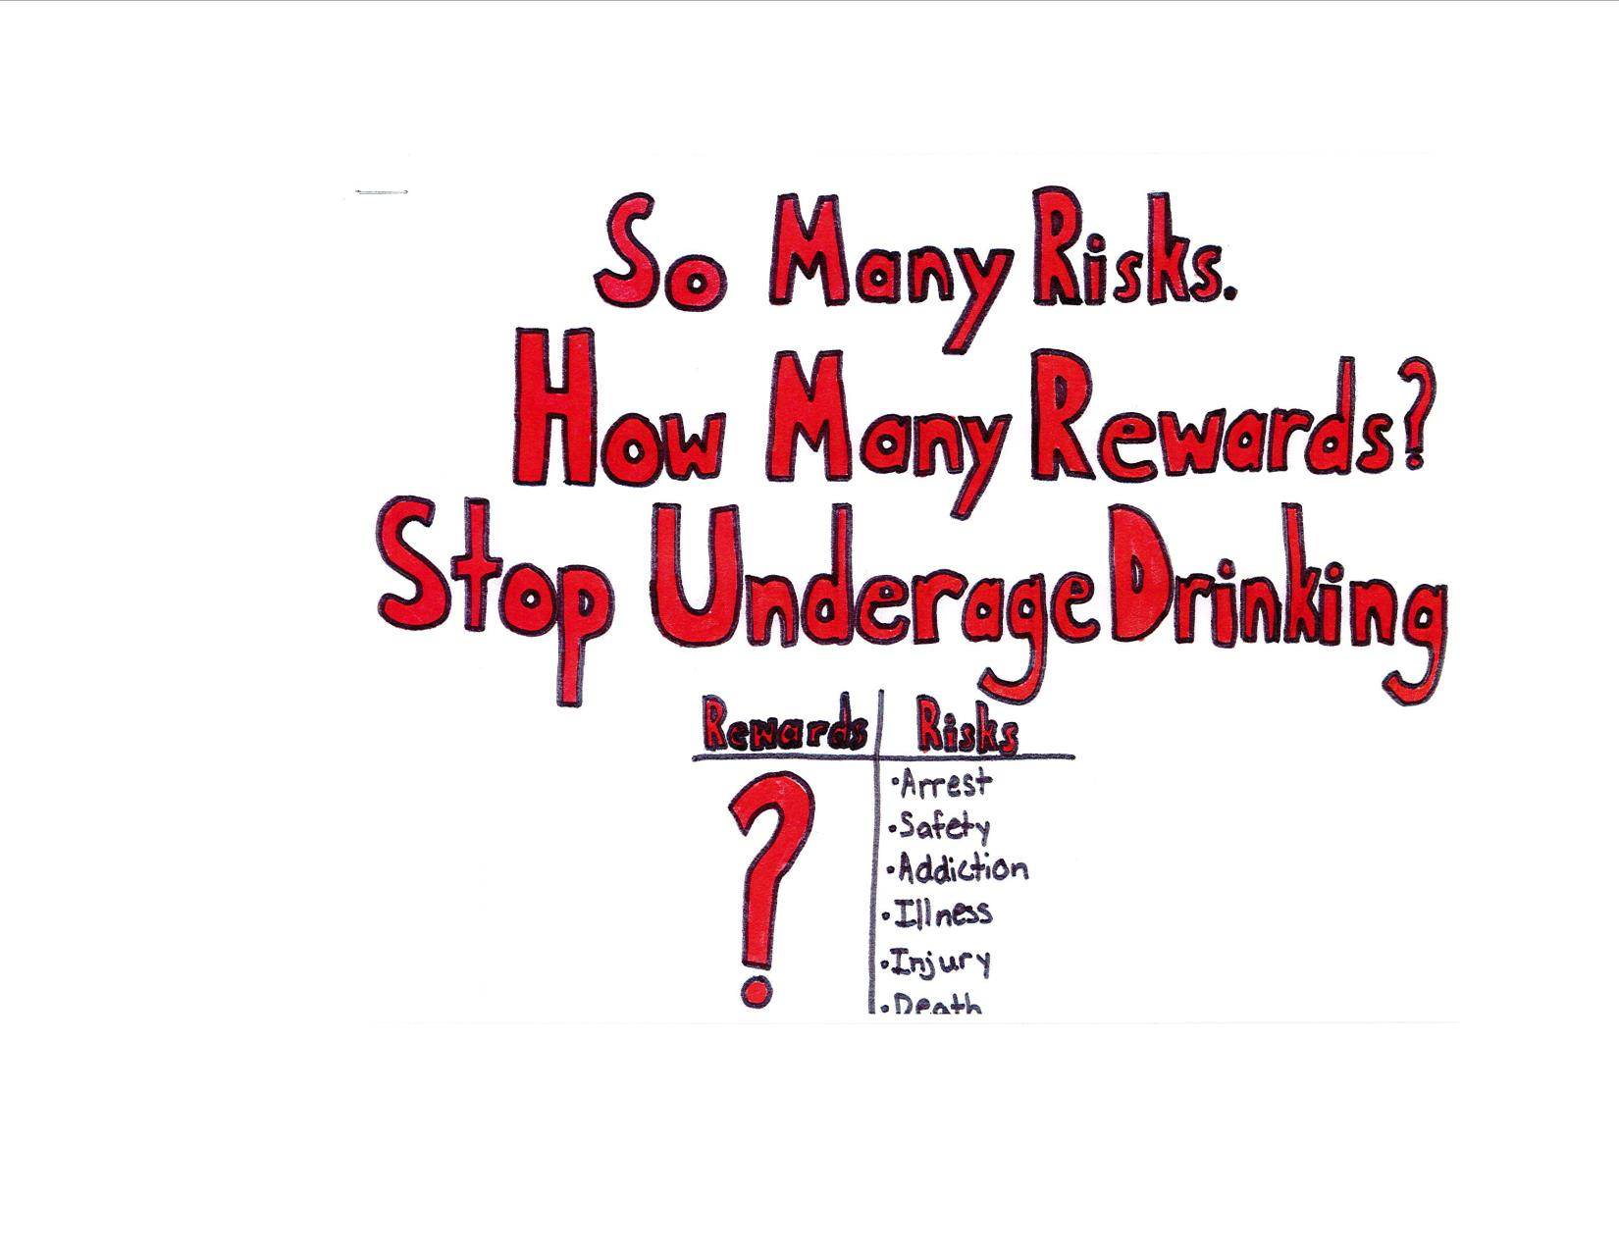

Second Place - Mia Hensley - Dana Lyons Middle School, Bath. Mia received a pizza party for her and her classmates.

Third Place - Desirea Stuart from Jasper-Troupsburg. Desirea received an ice cream social for her and her classmates.

Thank you to all the students and teachers that participated.

**Myth vs. Fact (Alcohol)**

* I can sober up quickly by taking a cold shower or drinking coffee.
* On average, it takes 2-3 hours for a single drink to leave the body.

**June 2016 Page 3 Volume 1, Issue 1**

**Myth vs. Fact: (Marijuana)**

* Marijuana is not as bad for you as tobacco.
* Marijuana is linked to respiratory problems just like tobacco. One marijuana joint has the same impact on an individual’s large lung airways as smoking 16 tobacco cigarettes.

**Upcoming Events:**

Next Coalition Meeting

September 14, 2016

11:00 am – Steuben County Sheriff’s Building

TIPS Training

August 9, 2016

6:00 pm – St. James Mercy Hospital

Youth Action Forum

October 25, 2016

Town Hall Meetings

TBD

Focus Groups

TBD



**MISSION:**

**To promote healthy and safe communities in Steuben County by reducing alcohol and drug use among**

**youths!**

