Save The Date
“A Community Conversation”
Town Hall Meeting

Wednesday, September 27th
Bath-Haverling Central School
25 Ellas Avenue, Bath, NY 14810
6:00PM –– 7:30PM

You will hear from Kami Wakim, RA - University of Rochester Neuroscience Program, relative to the effects of alcohol on the young developing brain.

This is EVERYONE’S Community

Please join community leaders, community members, educators, service providers and law enforcement – ready to discuss the issue in our community and the resources available to combat underage drinking.

Sponsored by:
Steuben Prevention Coalition
Steuben Task Force on Underage Drinking
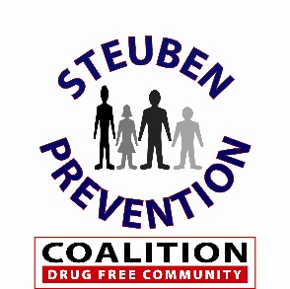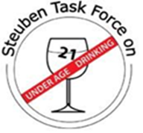

607-776-6441 ext. 202
www.steubenpreventioncoalition.org

