* **Tall Cop Report**
  + **March 29, 2017**
* **Website/Social Media Report** 
  + **Published as of January 17th**
  + **95% complete**
  + **Facebook Increase - Advertisements**
* **Coalition Report**
  + **By Law Revisions - Approved**
  + **Action Plans 2017 &2018 – Approved**
  + **MJ Logic Model – Approved**
  + **Successful Recognition Event**
  + **Continuation Applic. Due – Jan 27th**
* **Budget Report**
* **Underage Drinking Task Force Report**
* **Marijuana Prevention Task Force Report**
* **Other**

**Next Meeting: February 28, 2017**

# Steuben Prevention Coalition

# Steering Committee Meeting

**March 20, 2014**

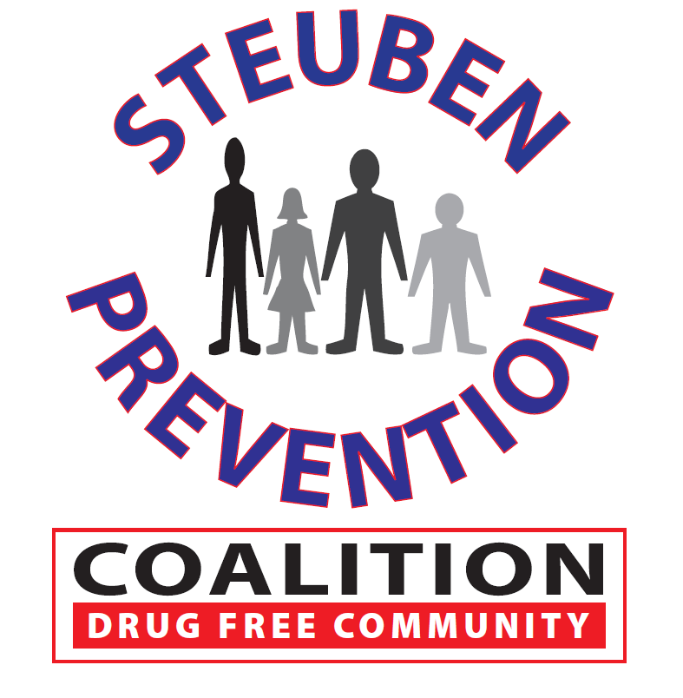

### Date: January 24, 2017

### Time: 9:00 a.m. – 11:30 a.m.

### Location: 115 Liberty Street, Bath, New York

## AGENDA