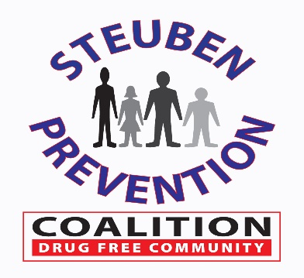
Colleen Banik
DFC Program Coordinator 23 Liberty Morris Street
Bath, New York 14810
(607) 776-8085
Steering Committee

Chair: Joe Rumsey

Co-Chair: Kory Bay

Recording Member: Colleen Banik

Member | Attendance | Member | Attendance
Jim Allard |  | Jesse Harper
Brooks Baker |  | Susan Hooker | X
Colleen Banik (Coordinator) | X | Kyle King (Consultant) | X
Stacey Wing |  | Irene Lawrence (Consultant)
Kory Bay | X | Nick Moffe
Jerry Bennett (Consultant) |  | Lisa Oliver
Brandon Beuter | X | Joe Rumsey | X
Amanda Chafee |  | Connie Terry (Staff) | X
Hank Chapman | X | Mike Gabrielli | X
Daniel Chapman | X | Guest - Kelli Keck | X
Bianca Crandle | X
Tom Crook
Kevin Grover

Meeting Minutes
January 25, 2022

Introductions/Welcome:

Chairman Joe Rumsey welcomed everyone, and no introductions were needed.

December Meeting:

The December 2021 meeting minutes were approved following a motion made by Joe Rumsey and seconded by Mike Gabrielli.

Budget Update:

Colleen Banik reported on the DFC Budget to date. A Budget report from the DFC Coordinator and Catholic Charities was presented via email prior to the meeting. Floor was opened for discussion. The Coalition currently has approximately $25,700 remaining of the 2021 Carry-Over monies and approximately $19,000 remaining on the Year 8 Grant budget.

Sustainability:

Colleen Banik reported that the Coalition is still actively seeking a replacement for business sector representative, Kevin Costello.

Action Item: Joe Rumsey will contact two individuals offline and report back to the committee.

The final slate of 2022 Chair and Co-Chair nominations was presented and approved following a motion made by Hank Chapman and seconded by Kory Bay.

2022 Nominations |  | Nominees
- Coalition | Chair | Hilda Lando - accepted
 | Co-Chair | Amanda Chafee - accepted
- Steering Committee | Chair | Joe Rumsey - accepted
 | Co-Chair | Kory Bay - accepted
- UAD & Marijuana Prevention Task Force | Chair | Stacey Wing – accepted - UAD
 | Chair | Audrey Bickle – accepted - MJ
- Opioid Task Force | Chair | Brandon Beuter - accepted
 | Co-Chair | Hilda Lando - accepted

Colleen Banik further reported that the Coalition was researching and preparing to apply for the OASAS Prevention Community Coalitions Grant opportunity. If awarded, this grant will provide support in the amount of up to $150,000 for a three-year period (individual award per year is required based on outcomes) to support substance use/misuse prevention-focused community coalitions to implement environmental strategies to reduce underage and binge alcohol drinking and/or heavy cannabis use. The application is due on February 17, 2022 with a potential award date in early March of 2022.

Coalition Update:

Colleen Banik provided a brief overview of the 2021 Prevention Needs Assessment Survey. Bach Harrison has provided the Steuben County Report and the individual school district reports. Analysis and Presentations are in progress. Early review is showing a generally across the board decrease in substance use with a few exceptions.

Kelli Keck presented the Epiphany Community Services Annual Evaluation Report for 2021. Kelli focused on the improvements, coordination, accountability, celebration and sustainability of the coalition. Kelli also provided the Committee with total outputs, efforts for general ATOD (all substances combined), specific to alcohol, specific to marijuana and specific to opioids. Kelli further recognized the Coalition success and provided recommendations for going forward. (See slides included below).

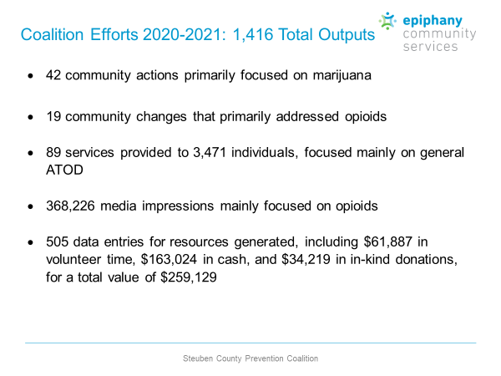
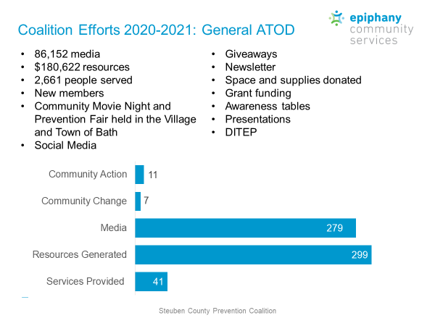
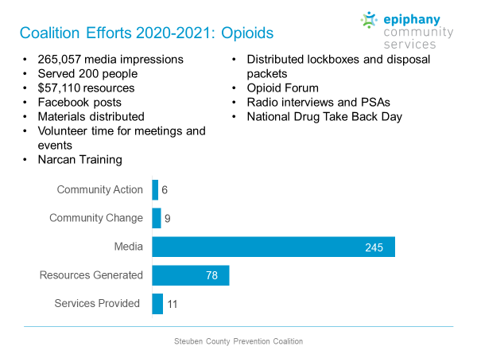
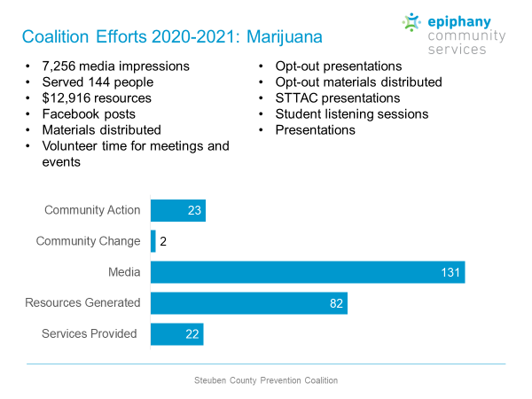
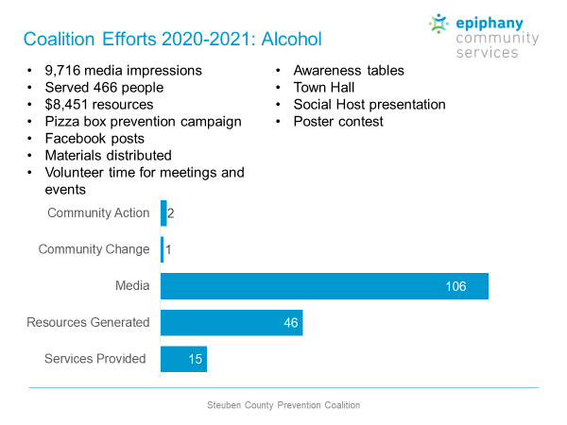
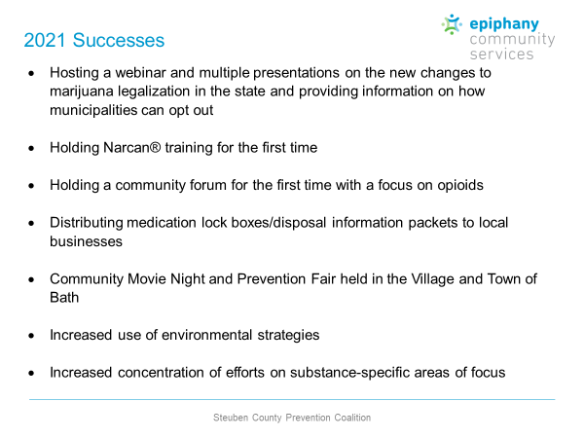
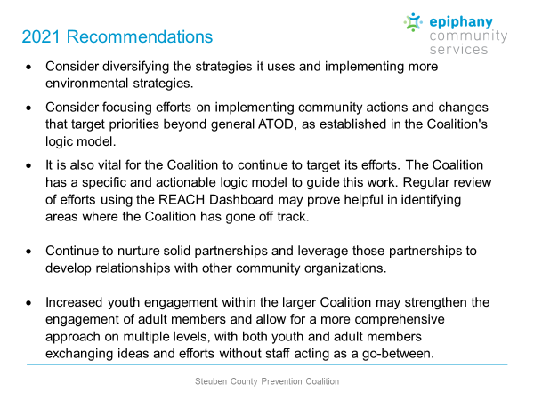
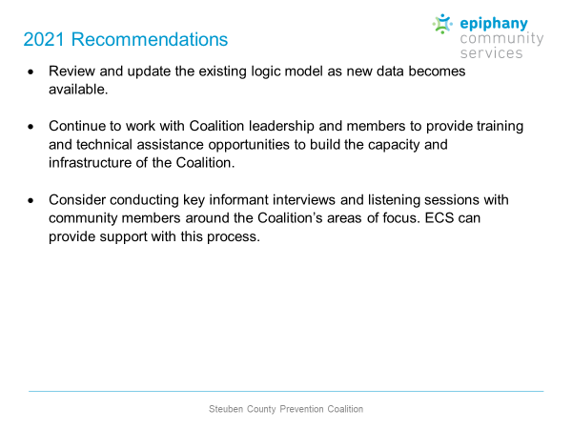

Colleen Banik reported that the results of the 2021 Coalition Self-Assessment Survey were presented to the full Coalition on January 12, 2022 with recommendations for going forward well received.

2022 By-Law and 2022 Community Involvement Agreement revisions were drafted and circulated to the Steering committee via email prior to the meeting to accommodate the addition of the Opioid Committee and it’s meeting structure and expectations as well as to combine the UAD and Marijuana Task Forces in an effort to reduce the amount of meetings needed to support requests made by membership and to increase the number of members available to work on both substance activities and events. It was also discussed by the full Coalition to reduce the bi-monthly coalition meeting time from 2 hours to 1 hours to better accommodate the needs of the membership and focus this meeting on the planning and carrying out of projects, events and activities. Drafted revisions to the By-Laws were approved following a motion made by Susan Hooker and seconded by Hank Chapman. Drafted revisions to the Community Involvement Agreement were approved following a motion made by Joe Rumsey and seconded by Bianca Crandle.

Opioid Committee Update:

Connie Terry gave an overview of the Opioid Committee activities to include the 2022 community Perception Survey in progress, Social Media activities, certification of Connie Terry as a Narcan Trainer, the Narcan training program in progress, OD Mapping update with 264 Overdoses and 15 fatalities ending 2021 and 23 Overdoses and 1 fatality to date of 2022. A Opioid Forum is being planned for February/March and billboards are already displayed with future billboard coming in March relative to the One Pill Can Kill campaign.

Underage Drinking Task Force Report:

Stacey Wing provided a written report presented by Colleen Banik:

- Poster contest will continue and be presented to schools and community partners in mid-February. Feedback was given that this a worthwhile project to continue and there are opportunities for other projects for UAD such as videos, sticker designs, etc.
- Superbowl round of stickers should be going out to businesses in the next few weeks.
- Recruitment for committed members is urgent, if each person could try to recruit someone over the next few months. With the combination of meetings with marijuana TF there is the opportunity to be multi-faceted with less meetings and more ideas.
- Speakers Bureau – we have some members interested in speaking at schools, if interested or know someone that is interested, please have them contact Stacey who works directly with the schools and classrooms to meet their needs, those of the students and this way we can have one coordinated effort.

Marijuana Prevention Task Force Update:

Colleen Banik reported that Audrey Bickle, Prevention Educator for Family Services Society, has taken on the role of Chair of the Marijuana portion of the newly combined Underage Drinking and Marijuana Prevention Task Force.

Other Items of Discussion:

Dan Chapman reported that following his interactions with the Village and Town of Bath, that both municipalities decided to Opt-In allowing marijuana dispensaries and opted out of on-site consumption sites. He also reported that the Village currently has 1 sticker shop providing marijuana as a gift upon the purchase of an item. The Village will be meeting with Sheriff Allard and DA Baker to discuss options to close this shop.

Meeting Adjourned:

The meeting was adjourned following a motion made by Joe Rumsey and seconded by Hank Chapman.

Action Item: | Who’s Responsible: | Target Start: | Target Completion:
Send 2021 Meeting Schedules to Chairs & Co-Chair, Committee Members | Colleen Banik | 12/18/20 | - 1/26/21
New Address/Location Information to PRC | Colleen Banik | 1/26/21 | - 1/26/21
Send additional request for MRTA clarification questions to Nick Moffe to be forwarded to Hilda Lando. | Nick Moffe | 4/27/21 | - 4/29/21
Report approval of expenditure to Council on Addiction of NYS. | Colleen Banik | 4/27/21 | - 4/28/21
Forward information relative to COANYS 2-Part Webinar Series to Kyle King and Irene Lawrence. | Colleen Banik | 4/27/21 | - 4/27/21
2022 By-Law Revisions/Approval | Colleen Banik | 1/1/22 | - 1/25/22
2022 CIA Revisions/Approval | Colleen Banik | 1/12/22 | - 1/25/22
Business Sector Representative Replacement of Kevin Costello | Steering Committee  Joe Rumsey | 12/8/21 | 2/28/22
School Collaborations – Outreach for Representation | Joe Rumsey  Kory Bay  Tom Crook  Jesse Harper | 1/1/21
Youth Action Forum – Planning Meeting | Joe Rumsey  Amanda Chafee | 1/1/21 | Needs Action by representatives
Superintendents Meeting – Stress the Importance of collaboration, administration and review of the PNA School Data Results | Joe Rumsey & Kory Bay | 1/1/21 | - 2/15/21

Next Meeting: February 22, 2022 @ 9:00 a.m.
(virtual until further notice – due to COVID19)

