* **Tall Cop Report**
  + **March 29, 2017**
* **Website/Social Media Report** 
  + **Published as of January 17th** 
    - **Complete & Ongoing**
  + **Facebook – Advertisements**
    - **Ad purchased & running**
* **Coalition Report**
  + **By Law Revisions - Approved**
  + **Action Plans 2017 &2018 – Approved**
  + **MJ Logic Model – Approved**
  + **Successful Recognition Event**
  + **Con’t. Applic. - Submitted 1/27/17**
  + **DFC Me Report – Submitted 2/16/17**
* **Community Drug Forum – 2/9/17**
* **Youth Engagement**
* **Student Surveys – Next Round**
* **Underage Drinking Task Force Report**
* **Marijuana Prevention Task Force Report**
* **Other**

**Next Meeting: March 28, 2017**

## AGENDA

# Steuben Prevention Coalition

# Steering Committee Meeting

**March 20, 2014**

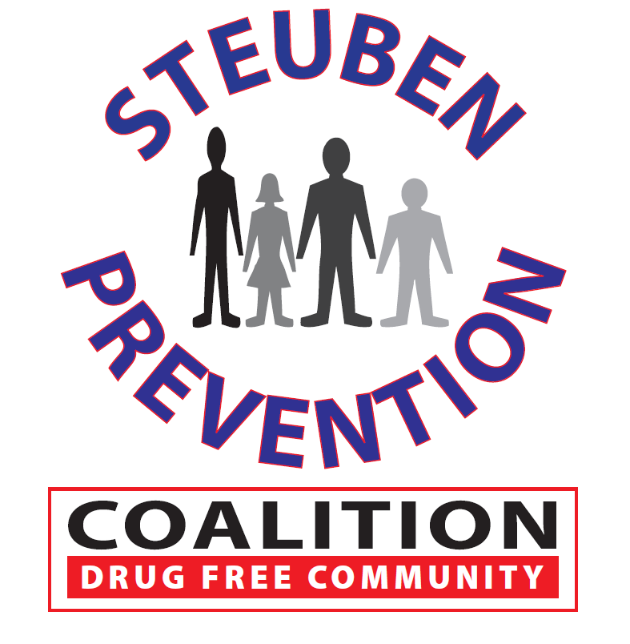

### Date: February 28, 2017

### Time: 9:00 a.m. – 11:30 a.m.

### Location: 115 Liberty Street, Bath, New York