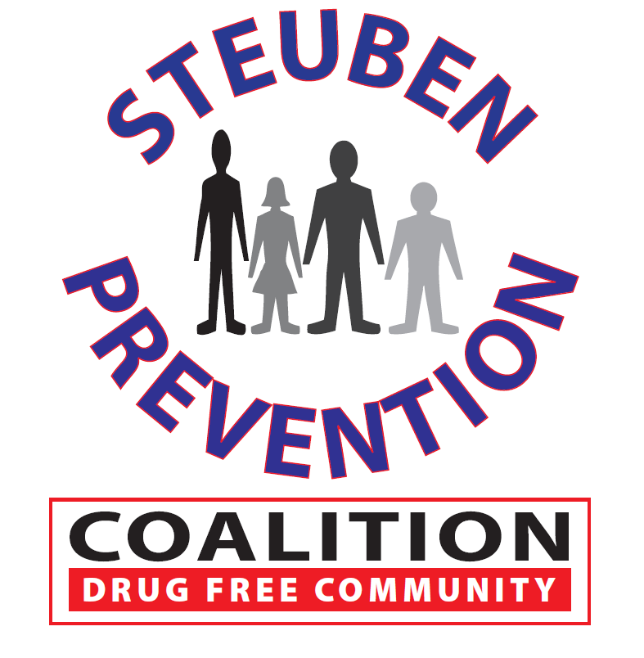

* Marijuana Project Update
* Marijuana Logic Model
* Magnets and Book Markers
* DITEP Outreach
* Tips for the Tool Box and other education material – what’s next?
* Opiate survey update
* New Poster?

### Time: 2:00 p.m.

### Steuben Council on Addictions

### 8 East Morris Street

### Bath, New York 14810

# Marijuana Prevention Task Force

**October 19, 2017**

## AGENDA