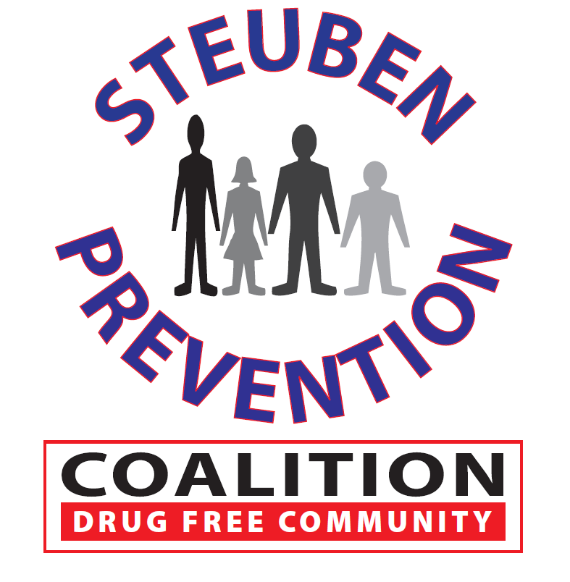

* Task Force Chair Introduction
* Co-Chair Recruitment
* Marijuana Campaign
  + Refresh
  + Start Date
* Other

Next meeting to be held on

December 20, 2018

8 East Morris Street, Bath, NY

### Time: 2:00 p.m.

### Steuben Council on Addictions

### 8 East Morris Street

### Bath, New York 14810

# Marijuana Prevention Task Force

**November 14, 2018**

## AGENDA