* Posters
* Recognition Letter
* PSA’s (radio ads) by 2 students
* Decide on PSA’s for movie theaters
* Meeting with YAF students at Bath High School (to start) Need to develop a list of actions we would like students to be involved in such as Peer to Peer project.
* Copies of Tips for the Tool Box for Mark to distribute to area schools
* Meeting with Jack wheeler (tomorrow) and John Buckley

Check out Thereisnodebate.org

Hashtag #noneedforweed

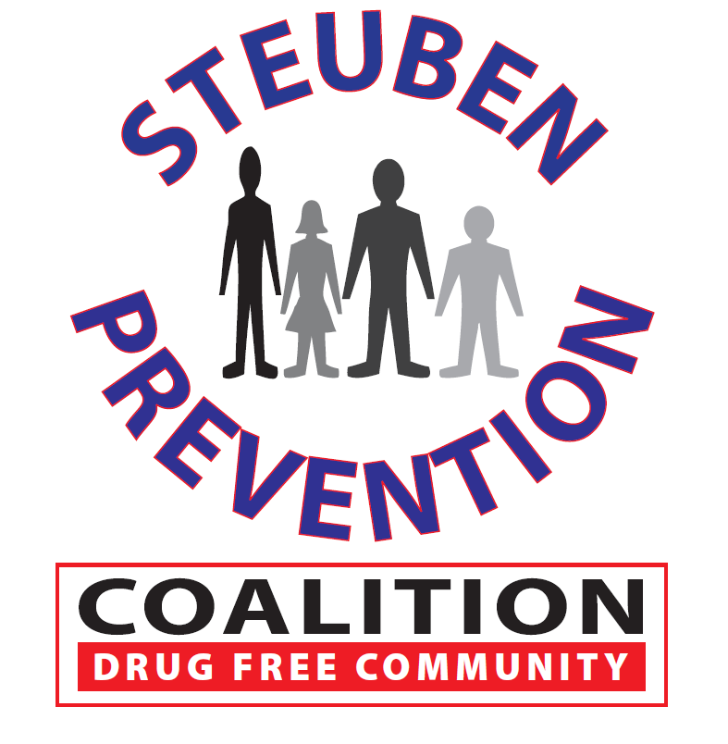

### Time: 11:00AM – 1:00PM

### Sheriff Office

**7007 Rumsey St. Ext.**

### Bath, New York 14810

# Marijuana Prevention Task Force

**March 8, 2017**

## AGENDA