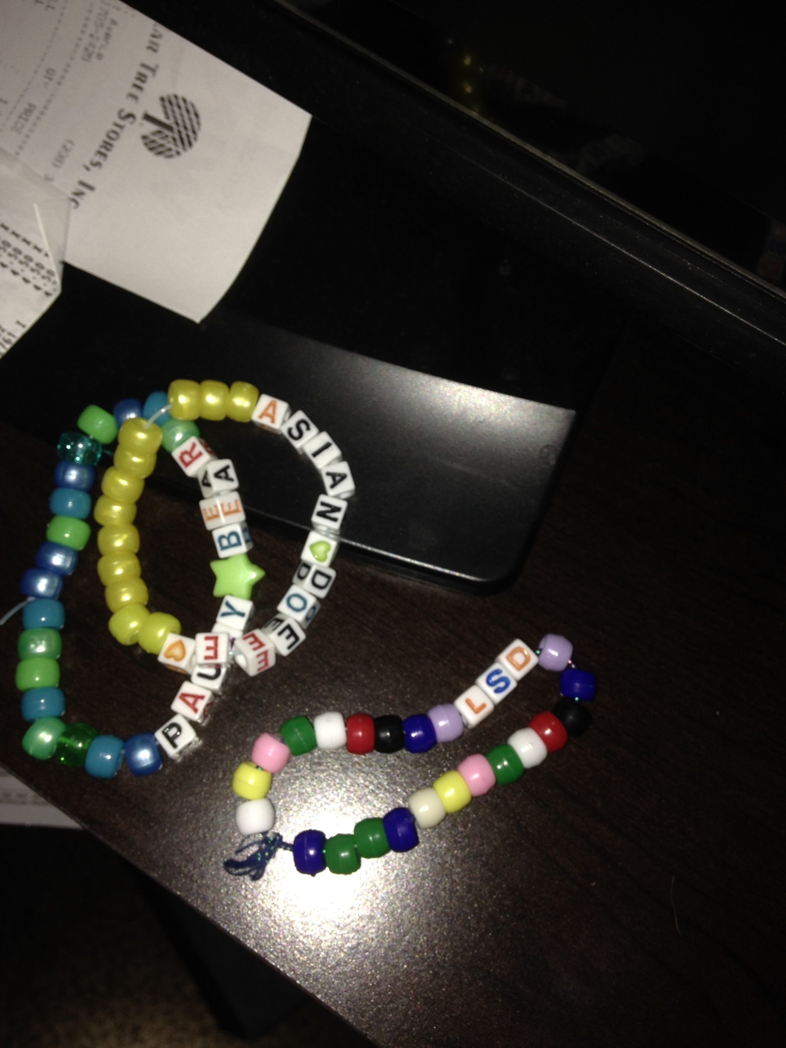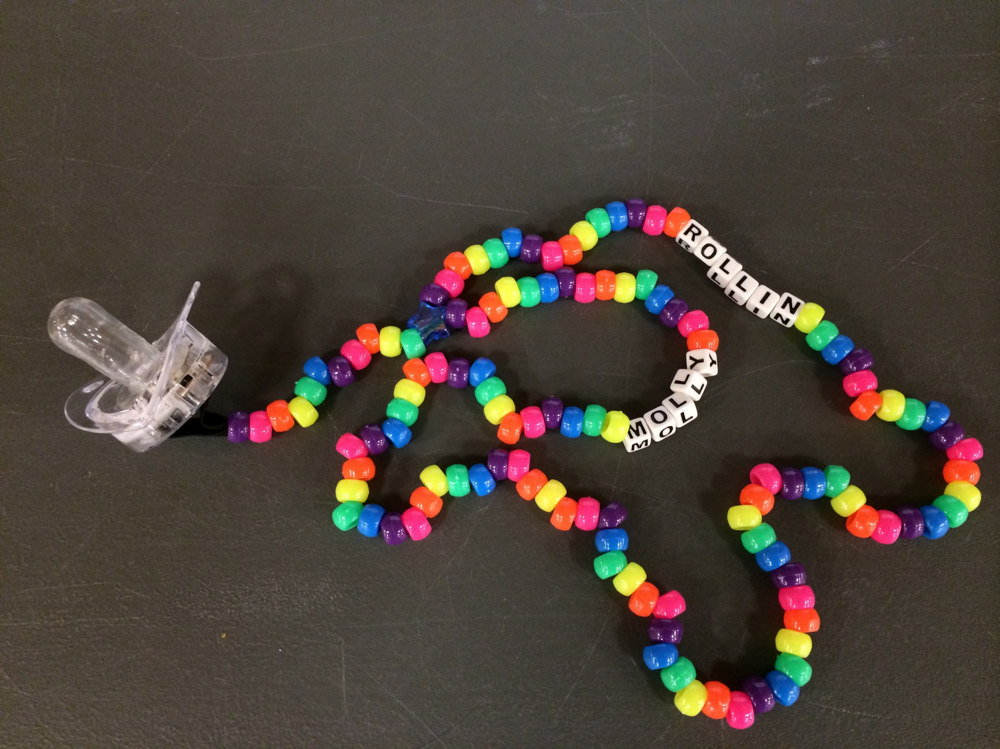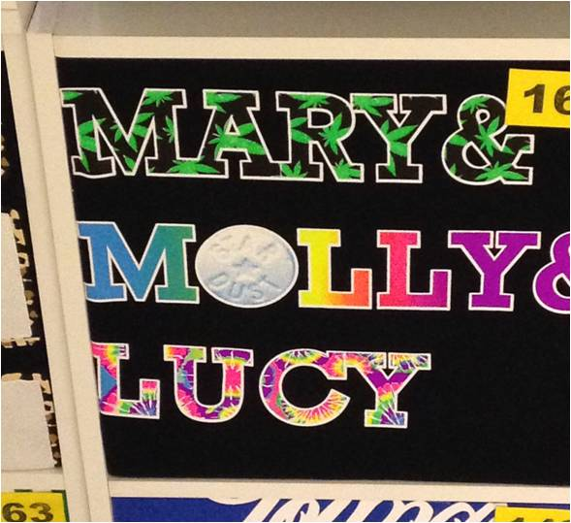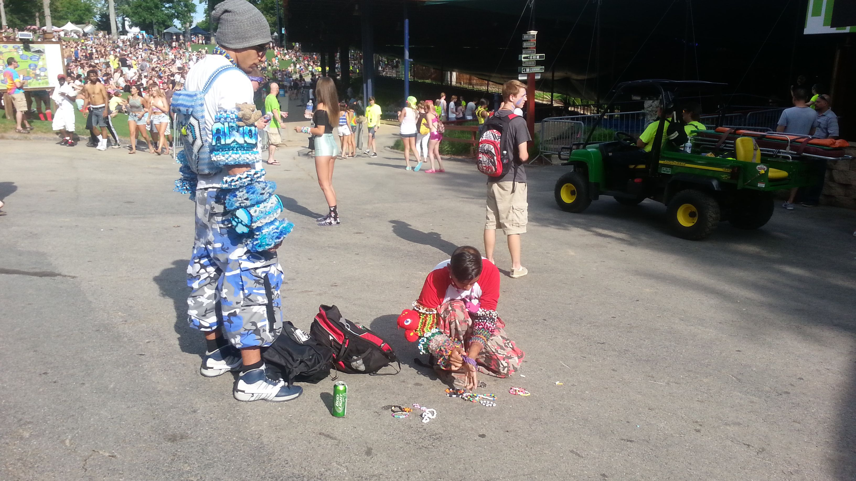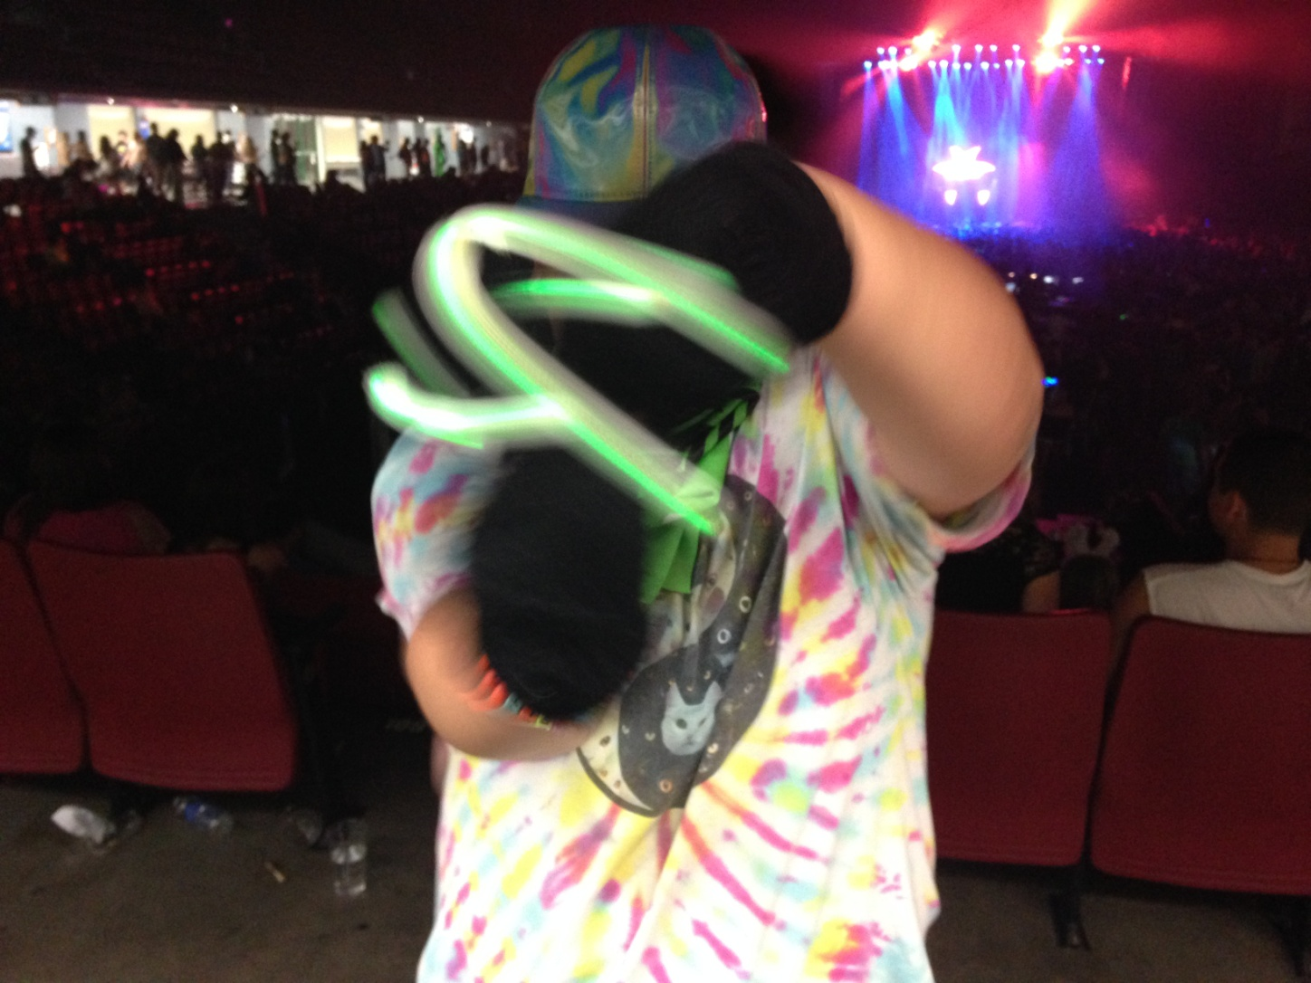

EDM

Trends & Culture

**WWW.TALLCOPSAYSSTOP.COM**

**What is EDM?** EDM stands for Electronic Dance Music. This music culture is a large but steady growing music culture with a large following of all ages. (The core age group is approximately 18-24 years old.) EDM type events can be associated with events formerly known as Raves. EDM events can have hundreds to thousands of attendees. They can be held at event centers, camp outs, a field in a rural town or even venues the size of motor speedways.

For years, we have seen overdoses (some being fatal) at these events. Designer drugs, combined with dancing and the heat, can be major contributors in the deaths. The sheer number of attendees can be overwhelming to law enforcement, emergency rooms, paramedics and the general community.

This bulletin shows some of the common themes that can be associated with these events. Please remember these are simply identifiers. Standing alone, the indicators could mean nothing, or they can possibly have an association with the drug world.

.05

##### Integer

Officer Jermaine Galloway

“TALL COP SAYS STOP”

Jermaine@tallcopsaysstop.com

**WWW.TALLCOPSAYSSTOP.COM**

**Things to Consider:**

These events are promoted under many different names that don’t make strong references to EDM. TERMS to pay attention to: “galactic”, “out of this world”, “out-of-body”, or “universe-type experience”. This is the same type of experience, many people who are hallucinating, will report.

Since many events are all ages, we tend to have young attendees present at the events. Depending on the laws and the policies of the location, alcohol might still be served. Without 21-and-over restrictions, it can be difficult to keep the alcohol away from minors.

Recently a handful of overdose deaths have made it into the national media:

June 2015 Washington DC

June 2015 Chicago Illinois

June 2015 Las Vegas Nevada

***OTHER POPULAR DRUGS:***

Various synthetics such as spice, bath salts, flakka, marijuana, and alcohol mixing.

***ADDITIONAL ITEMS:***

Glow sticks, finger lights, pacifiers, stash compartments, vape pens, clothing that focuses on out-of-world or out-of-body experience and inhalants.

***TERMS & LOGOS***

***KANDY or KANDI***

The colorful, possibly plastic, jewelry-like items, including: beaded bracelets or necklaces

that may have drug, party or alcohol terms beaded into the bracelet

***PLUR***

Stands for Peace, Love, Unity and Respect - A Popular Culture Term

***MOLLY***

A slang term for the drug Ecstasy

***LUCY***

A slang term for LSD

***TRIP or TRIPPIN***

Slang for being high or high on Acid / LSD

# **EDM Trends and Culture**

# o

**WWW.TALLCOPSAYSSTOP.COM**