The Sweeping Trend of Dabbing & Marijuana Concentrates
There is a new trend that is currently sweeping the country and is overwhelming some law enforcement, educators, safety officials, and parents. The term for this new trend is called “dabbing” but at a street level it is referred to as marijuana wax, oil or concentrates. As many would expect when they hear the word marijuana, what comes to mind is a green leafy substance that is smoked through a glass marijuana pipe or a bong. The first thing that you need to do is get that image, knowledge of standard paraphernalia and terms out of your mind. This “new” marijuana is completely different than anything we have dealt with in the past. Some of the initial names are WAX, Budder and BHO (Butane Honey Oil or Hash Oil).
What is marijuana concentrates? Marijuana concentrates are the extracted resins from green leafy marijuana which can raise the THC content from the standard street level 15% THC to 60-90% THC. Also, concentrates are not green or leafy…they look like wax, butter, oil or amber colored glass shards, called “shatter” (see photo #1). Concentrates are commonly extracted using butane (when run through the dry herbal marijuana buds it extracts the THC). The watery/waxy THC is then heated to bubble off the butane. The use of butane is not the only method to create concentrates, but it is the most popular. Once packaged, this product can simply look like a small portion of wax. Concentrates can also be laced with other drugs or put into various food products. Obviously, this changes the delivery method and makes identification more discrete.
Using butane, a common fuel, for extraction, has its problems. The use of butane has caused multiple explosions all over the country, including one in a university housing complex near the University of Montana, in October of 2014 and countless more in 2015. These explosions have killed and severely burned people of all ages, nationwide.
Dabbing has many street names: dabs, butter, budder, amber, honey, oil, or BHO. You will also see clothing or items with the term “710”. This term is similar to the street level term of 420 which is the universal time and date to get high. In this case, 710 is the word “OIL” turned upside down (see photo #2), making it a popular drug reference.
Along with the incredibly high THC, marijuana concentrates have some non-traditional symptoms. Some users report hallucinations, passing out, extreme highs (even from small portions), along with high levels of impairment. This high impairment has led to some

Individuals overdosing on the product including an incident late last year involving teenagers in southern Utah.
Advanced Paraphernalia: After creating the marijuana concentrate, the subject uses a more specific bong or pipe which is called an “Oil Rig” to smoke the wax. A popular trend is to use a device that looks like a standard e-cigarette, specific to concentrates and oils, for use of various marijuana-based products instead of nicotine. These devices have electric heating sources and are made for smoking wax, oil, dry herbal marijuana or shatter. These e-cigarettes are very discrete and “stealthy” and can be hard to identify as drug paraphernalia while putting off very little odor.
The “dabbing” movement is extremely popular, evolving quickly and there are many different types of paraphernalia, terms, logos, and concentrate types coming into our communities. As this trends popularity continues to skyrocket with individuals of all ages, we need to continue to educate ourselves on the dangers and paraphernalia associated with the trend of “dabbing”.
Another Way of Use of High Potency Marijuana-Edibles (food):
Edibles are not your everyday foods or candy. Edibles are items that are laced with various levels of THC content. The most difficult part of marijuana edible is that it can look like many everyday item. There have been documented overdoses of marijuana edibles due to the fact that most people don’t realize how much of the drug they are actually consuming. There are plenty of news articles out there that highlight the impact of marijuana edibles. Some of these items are sold over the counter in some states. Law Enforcement and Educators in many states have located various types of illegally possessed marijuana edibles on minors and adults.
Terms, Logos & Identifiers:
- BHO-Butane Honey Oil or Butane Hash Oil
- Budder, Butter or Wax/Oil
- Concentrates or Essential Oils
- Shatter or Crumble
- Amber, Honey or Nectar

***
This was a basic training bulletin prepared by Idaho Officer Jermaine Galloway “The Tall Cop”. For more specific information on dabbing, drug concentrates, paraphernalia, BHO explosions, and this trend, contact Officer Jermaine Galloway:
Jermaine@tallcopsaysstop.com or www.tallcopsaysstop.com

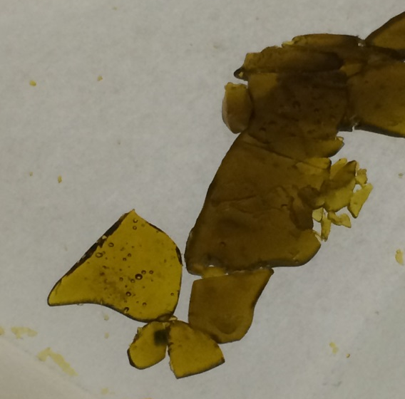

Photo #1
Photo #2
710 / OIL

