SeptDecemberapriFebruary

**September 2019 Volume 4, Issue 9**

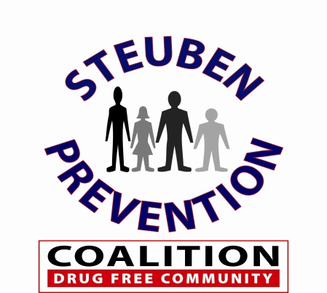

Ounce of Prevention

Newsletter

**Message to Coalition Members:**



The Steuben Prevention Coalition would like to welcome Pansy VanTreese, DSS Drug Court Representative, Mallory Wolverton, Program Assistant for the Institute for Human Services and Breanna Wilson, Cherokee Stratton, Victoria Wagner and Brandon Beuter from AIM Independent Living to the Coalition as volunteer members. We are looking forward to working with all of you!

**COALITION WEBSITE & FACEBOOK PAGE**

Don’t forget to visit our Website and our Facebook Page and invite your friends to view and like our page as well.

[**http://www.steubenpreventioncoalition.org**](http://www.steubenpreventioncoalition.org/)

**Inside this Issue:**

* Message to Coalition Members – Welcome
* What’s Happening in Your Community
* 2019 Adult Perception Survey Closed
* U.S. Surgeon General Marijuana Advisory
* Vaping & Other Teen Drug Trends
* Opioid Overdose Warning Signs – Video Link
* Coalition Opioid Outcome Data
* Upcoming Events

**Steuben Prevention Coalition**

**8 East Morris Street**

**Bath, NY 14810**

**(607) 776-6441**

**Website:** [www.steubenpreventioncoalition.org](http://www.steubenpreventioncoalition.org)

**Email:**

steubenpreventioncoalition2017

@gmail.com

**Staff:**

**Colleen Banik**

**Program Coordinator**

**cbanik@dor.org**



**We are asking all Coalition Members and Community Partners to let us know of any upcoming events, activities, public meetings, etc. that are or will be happening in your communities. Please contact us at the information provided.**

[**cbanik@dor.org**](mailto:cbanik@dor.org)

**2019 Adult Perception Survey**



The Steuben Prevention Coalition launched the 2019 Adult Perception Survey on July 29th. This survey is now closed as of August 30th with over 250 responses.

We circulate this survey in order to gain a better understanding of the picture adults see as issues and concerns in our communities.

Please stay tuned for the 2019 results and thank you for your participation.



**September is National Recovery Month**

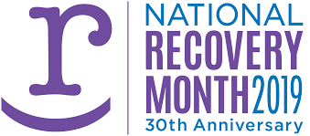

Every September, the Substance Abuse and Mental Health Services Administration (SAMHSA) sponsors Recovery Month to increase awareness and understanding of mental and substance use disorders and celebrate the people who recover.

**U.S. Surgeon General – Marijuana Advisory**

*CADCA News Roundup – Coalitions Online*

August 29, 2019

This morning, for the first time in 37 years, United States Surgeon General Jerome M. Adams issued a Surgeon General's Advisory on marijuana, becoming the first Surgeon General to do so since former Surgeon General C. Everett Koop's in 1982.

Joined by U.S. Department of Health and Human Services Secretary Alex Azar, Assistant Secretary for Health Admiral Brett Giroir, Assistant Secretary for Mental Health and Substance Use Dr. Elinore F. McCance-Katz, and Director of the National Institutes of Health (NIH) National Institute on Drug Abuse Dr. Nora D. Volkow, Surgeon General Adams hosted a national press conference to share the details of his [Advisory on Marijuana Use and the Developing Brain](http://www.mmsend36.com/link.cfm?r=ePbJHfqf809e_gxX1SCxCg~~&pe=O4Bsk6t1PAxl7jOZC5jn7YJoUZVYnIUO3EDXxrXjuz8kUS4uB0OCZ6zufvpEqkFZMWFbDPQHnaIcz-qb193UOA~~&t=hac0YiKBDeXkbXMmpHhlag~~). During the press conference, Surgeon General Adams urged health leaders and prevention advocates to convey that "no amount of marijuana use during pregnancy or adolescence is safe."

In his Advisory, Surgeon General Adams asserts that "marijuana can impair learning in adolescents," with chronic marijuana use "linked to declines in IQ and school performance that jeopardizes professional and social achievements and life satisfaction." He goes on to emphasize that "marijuana use is also linked to risk for and early onset of psychotic disorders, such as schizophrenia" and "adolescent marijuana use is often associated with other substance use."

General Arthur T. Dean, CADCA's Chairman & CEO, was invited to attend the press conference, and his thoughts on the advisory are included in a [press release issued today by CADCA](http://www.mmsend36.com/link.cfm?r=ePbJHfqf809e_gxX1SCxCg~~&pe=jhb-A0WWkfRnAVTH5c6KUZAeotyDM9uBOIg-ovroeNyoKpYvcP7NN37mW7hC1KEqjGl0v5nID5ocFEf_0etaaA~~&t=hac0YiKBDeXkbXMmpHhlag~~). General Dean believes that "...in accordance with the science and medical research developed by NIH and endorsed by Surgeon General Adams, adolescent marijuana use is unsafe and can have extremely detrimental effects on the developing brain."

[**https://www.hhs.gov/surgeongeneral/reports-and-publications/addiction-and-substance-misuse/advisory-on-marijuana-use-and-developing-brain/index.html**](https://www.hhs.gov/surgeongeneral/reports-and-publications/addiction-and-substance-misuse/advisory-on-marijuana-use-and-developing-brain/index.html)



**September 2019 Page 2 Volume 4, Issue 9**

**September 2019 Page 3 Volume 4, Issue 9**

**Vaping and Other Teen Drug Trends**



Vaping and Other Teen Drug Trends – Presented by Michael DeLeon from Steered Straight, Inc.

Date: November 20, 2019

Time: 1:00 – 2:30 p.m.

Location: Bath-Haverling High

School Auditorium

Cost: $25 per person

Alfred State College’s Center for Community Education and Training, the Steuben Prevention Coalition and Bath-Haverling High School have teamed up to bring the “Steered Straight” program to the Southern Tier! We are in one of the worst public social health crisis’ America has ever seen with vaping/JUULing and marijuana legalization. This presentation will tell us what educators and parents need to know about these new trends. The threats to youth have changed, and the terminology you thought you understood needs new understanding. What are the conversations you need to have with your students or children? Where does connection fit in with this digital world?

You can email ccet@alfredstate.edu to register or use the following link to register online:

<https://banner.alfredstate.edu/pls/prod/zwskcenc.P_SelectCourse>

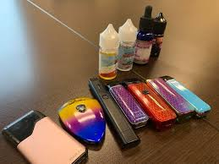

**Opioid Overdose Warning Signs**

NYS Office of Alcoholism and Substance Abuse Services (NYS OASAS) is pleased to share a campaign as part of their prevention efforts. The new campaign will focus on making sure individuals know how to recognize an overdose and to call 911 if they suspect someone has overdosed. Also mentioned in this is the importance of Naloxone as it can save a life and the Good Samaritan law.

The “Suspect an Overdose” campaign includes a video that will be streamed on digital throughout the summer and fall. Please help to spread the word.

Video Link:

<https://youtu.be/ZZRyHfX-VaE>

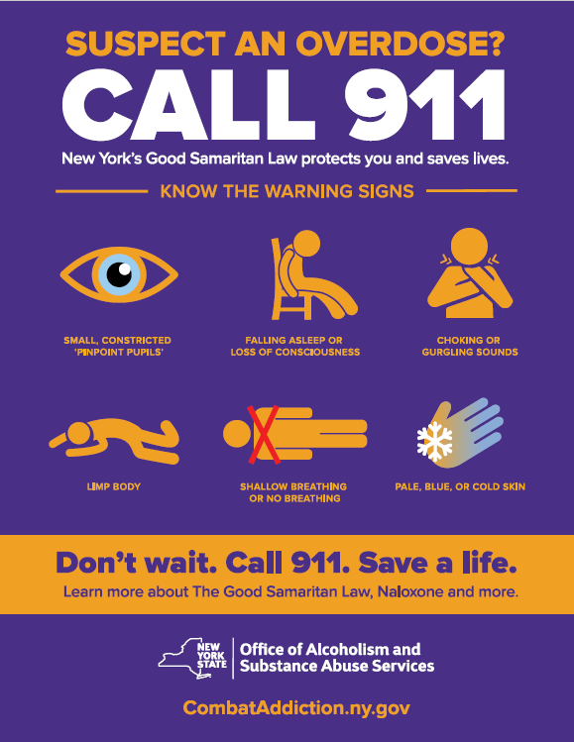

**Septemver 2019 Page 4 Volume 4, Issue 9**

**Steuben Prevention Coalition Opioid Outcome Data**







**Upcoming Events:**

**Next Coalition Meeting**

**September 11, 2019**

**11:00 am – Steuben County Sheriff’s**

Strong Kids – Safe Kids Event

September 14, 2019

12:00 – 4:00

Steuben County Fairgrounds

Youth Action Forum

Bath-Haverling High School

September 24, 2019

Youth Led Café Conversation

Corning

(TBD)

Underage Drinking Task Force

Town Hall Meeting

(Fall 2019 – TBD)







**Steuben County Underage Party & Drug Information Tip Line**

Anyone with information relating to underage drinking such as parties, underage sales, etc. or information relating to illegal drugs, such as sales, dealers or other suspicious activities are encouraged to use the tip line.

**The Tip Line will be monitored seven days a week, 24 hours a day. All call are anonymous.**

**Do your part to help make our communities safe for everyone.**

**1-844-378-4847**

**MISSION:**

To promote healthy and safe communities in Steuben County by reducing alcohol and drug use among our youth!

**VISION:**

To have a county where our youth are healthy and drug free!